G.U.I.D.E AI: Goal-based Upskilling & Intelligent Direction Engine for Personalised Career Guidance

VANSHIKA JANGRA
School of Computer Science and Engineering, Vellore Institute of Technology, Chennai, India¹

Abstract – Today’s technology landscape is evolving very rapidly and most of the students face difficulty to choose a career paths as they do not receive personalized guidance. The platforms that currently exist do not consider the ability of the students, their interests and their learning capacity as they provide generalized recommendations. The proposed project is a AI-based career guidance system that is called G.U.I.D.E AI. It analyses the inputs that are user-specific i.e. skills, interests, academic performance, and available study time. This is to generate tailored career recommendations and provide structured learning roadmaps. The implementation of this system is done by using a modern web-based architecture where frontend is implemented by using React and the backend is implemented by using Node.js integrated with MongoDB for data storage. The frontend and backend are implemented and fully shows AI generated outputs using the structured data. The initial results have shown the interaction between user flow and recommendation which lays te strong foundation for further AI based automation and be backend integration.

I. INTRODUCTION
Today’s technology landscape is evolving very rapidly and most of the students face difficulty to choose a career paths as they do not receive personalized guidance. The platforms that currently exist do not consider the ability of the students, their interests and their learning capacity as they provide generalized recommendations. The proposed project is a AI-based career guidance system that is called G.U.I.D.E AI. It analyses the inputs that are user-specific i.e. skills, interests, academic performance, and available study time. This is to generate tailored career recommendations and provide structured learning roadmaps. The implementation of this system is done by using a modern web-based architecture where frontend is implemented by using React and the backend is implemented by using Node.js integrated with MongoDB for data storage. The frontend and backend are implemented and fully shows AI generated outputs using the structured data. The initial results have shown the interaction between user flow and recommendation which lays te strong foundation for further AI based automation and be backend integration.

II. BACKGROUND STUDY
Career recommendation systems is a type of recommendation system that help guide people to choose a suitible career. It looks at user's information like skills, interests, or background and suggests options that may fit the user well.
In these systems, they sometimes use simple, basic rules to match for careers, or use machine learningn(ML) models to make better suggestions. Both methods can also be used together to give more accurate results.

Key concepts involved include:

Recommendation Systems: They are systems which filter available options based on the input given by the user and then suggest the relavant options to users.
User Profiling: It consists of collecting and then structuring user data such as skills, interests, as well as academic performance, and other
Artificial Intelligence: It is used to analyze patterns and generate meaningful suggestions based on the analyzed data of the user.
Learning Roadmaps: They are structured sequences of steps that guide users towards achieving a specific aim or goal.
In this project, all of these concepts have been combined to create a system that not only recommends careers but also provides the actionable steps required to achieve them.

III. LITERATURE SURVEY
Many research works and studies have worked on smart career recommendation systems:A study on AI-based career guidance systems shows the importance of personalized recommendations using machine learning algorithms.Research on student profiling systems talks about how checking a student’s skills can help give them more accurate career suggestions.One paper on hybrid recommendation systems explains how using both rules and AI together can give better results for recommendations.Studies on educational data mining show that student data can be used to guess which career path may suit them.Research on decision support systemsshows that step-by-step processes can help users make better decisions.
Research Gap:
Most existing career recommendation systems have the same common problems:
They mostly give very generic suggstions that are not very personal. A lot of them will not provide a clear step-by-step learning path. And users can feel confused about what to do next. They also don’t consider how much time a person actually has to learn or prepare.
Many systems are not very interactive or easy to use, which can make the whole experience boring or difficult for users. As a result of which people may not fully benefit from these systems.
The proposed system tries to solve these problems in a better way:
It takes more personalized inputs from the user, like their skills, interests, and preferences. It also then creates a proper structured roadmap, so users can clearly see what steps to follow.

The system also focuses to try to have an interactive and user-friendly design, so it is easier and more engaging and encouraging to use. Thus it aims to give a more useful and practical career guidance compared to existing systems. 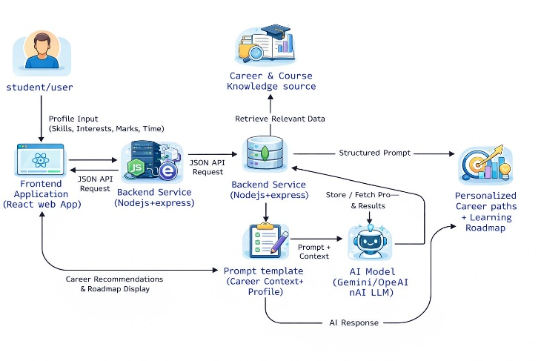

​V. PROPOSED SYSTEM
The system that we are proposing, G.U.I.D.E AI, is helpful in providing personalized career guidance to users using AI insights and analysis along with user data. The key features of the proposed system involve:
The main feature is recommendation based on user profile section data that includes information about user's academic background, skills, goals and generates a career roadmap focused upon the user.
After the profile analysis is completed, the system generates career paths aligned with user's strengths and goals.
Each career path that is recommended by the system is supported using a metric known as confidence score that is a measure of reliability and relevance of the recommended path.
The roadmap generated also outlines the necessary skills and milestones required to achieve the selected career path.
The system also suggests relevant courses and resources required during the learning journey for skill development.

The overall workflow is as follows:
The user enters profile details into the system such as educational qualifications, interests, and skills.
The profile data is then sent to backend and AI models for processing user data.
The AI module then generates and suggests suitable learning career paths using the saved data.
The interactive dashboard displays the results from above step, including career paths, confidence scores, and a detailed learning roadmap.

Novelty:
Career recommendations are combined with learning paths generation in a single structured platform.
The platform includes time-based learning planning to keep a track of user progress and visualize it over weeks and months.
The suggestions are personalized, dynamic and is displayed using an interactive dashboard-base user interface with an actionable guidance. 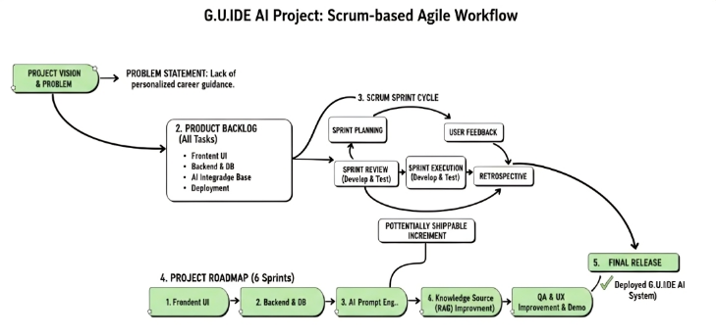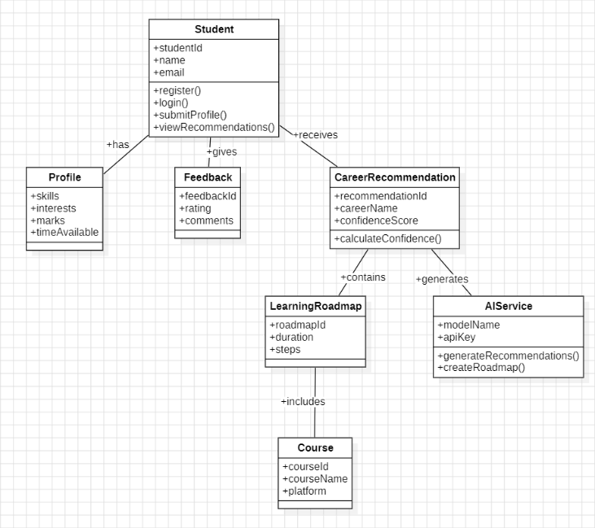

VI. SYSTEM ARCHITECTURE
The system is a client-server based architecture that ensures scalability, flexibility and efficient data processing. The components involved are:
Frontend is built using React that provides interactive user interface and facilitates input collection and result visualization along with responsive user interface.
Backend consists of Node.js and Express framework that handles AI integration along with API request.
Database is based on MongoDB for storing user data, AI career path recommendations, and historical data for future purposes.
AI module is a Large Language Model(LLM)-based system to generate intelligent and user specific career recommendations after processing user profile data.

System Flow:

User → Frontend → Backend → AI Model → Database → Response
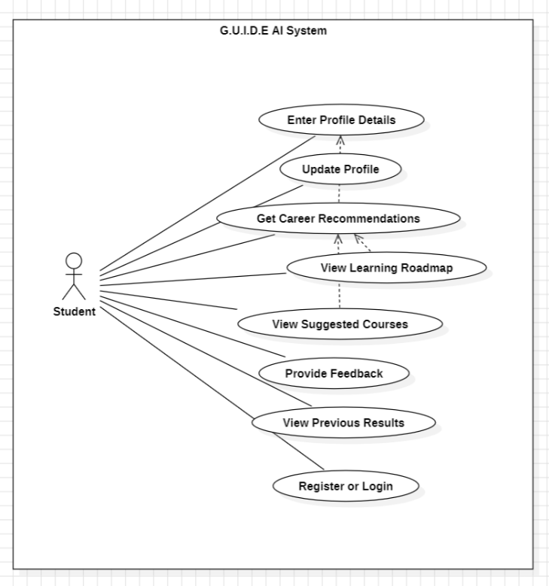

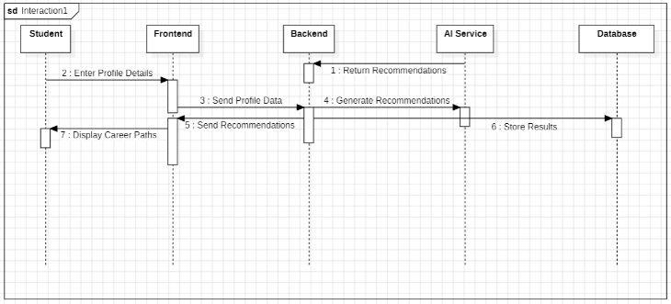

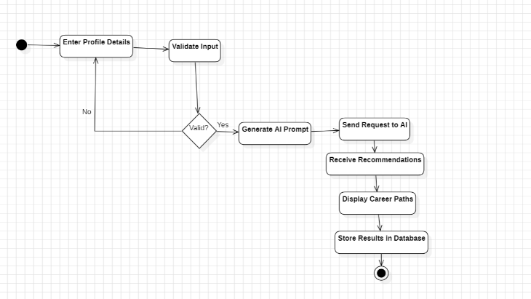

VII. PROTOCOL STACK

A layered-architecture is followed while developing the system to ensure modularity and maintainability of the system. Each layer has a specific functionality and is described in detail below:

Presentation Layer: This layer handles user interaction and data presentation along with visualizations. It is implemented using the React-based frontend stack.
Application Layer: This basically handles the core business logic of the proposed software that manages data processing, API communications and AI module interactions. This is build using Node.js and Express
Data Layer: This layer is responsible for handling all the data flow inside the system and storing data for each user while managing flexibility and system scalability. This also maintains user profiles, recommendations history from the AI module and system logs.
AI Layer: This is the core intelligence of the system that uses a LLM-based model analyzing user-specific data to generate personalized career roadmap recommendations. This is responsible to produce personalized outputs involving career paths, confidence scores and learning roadmaps and skills.

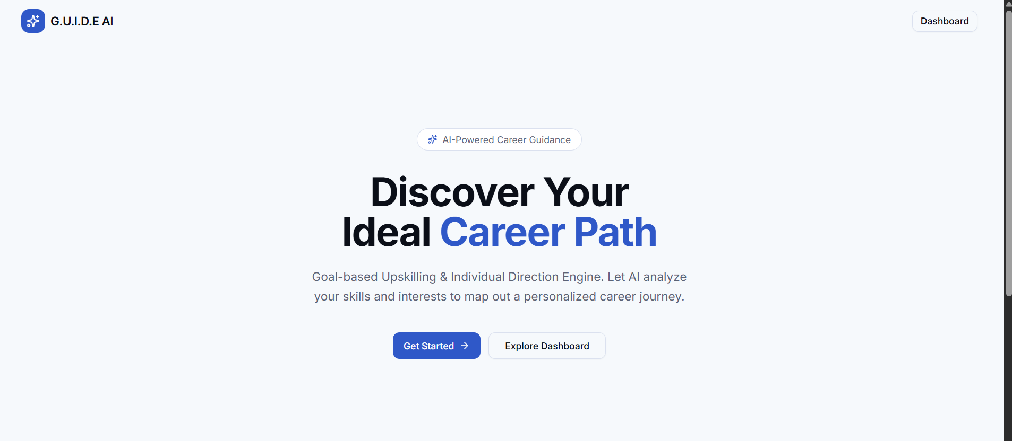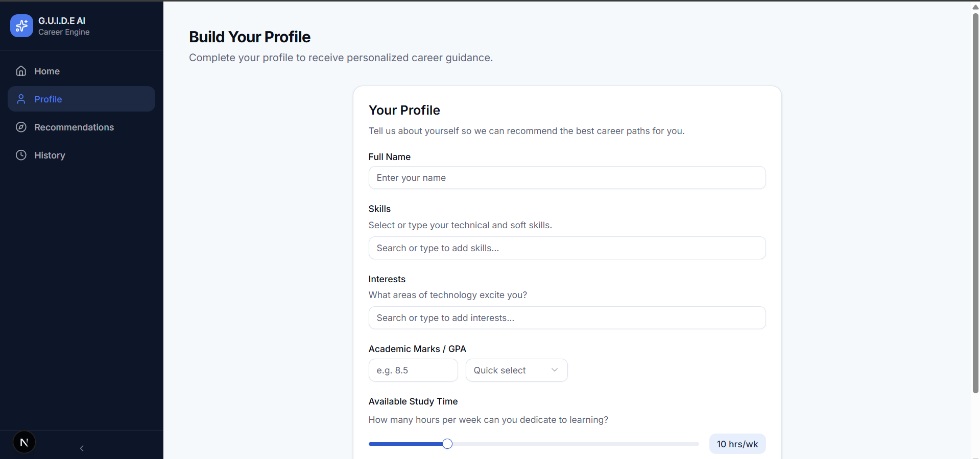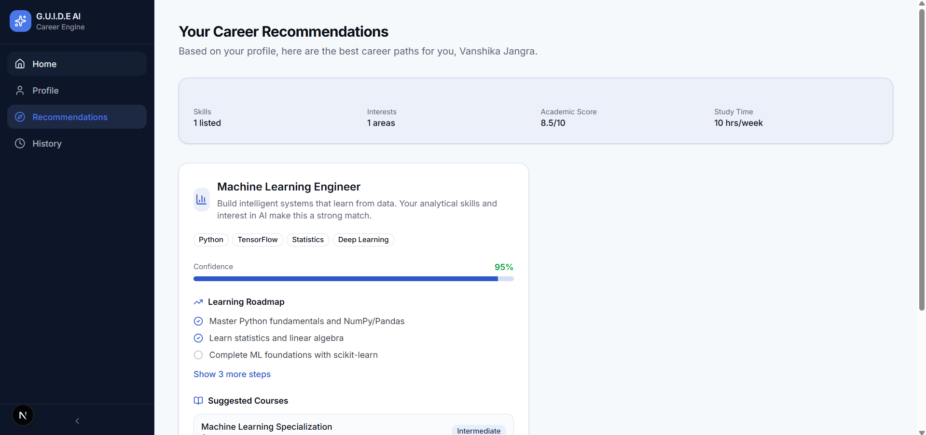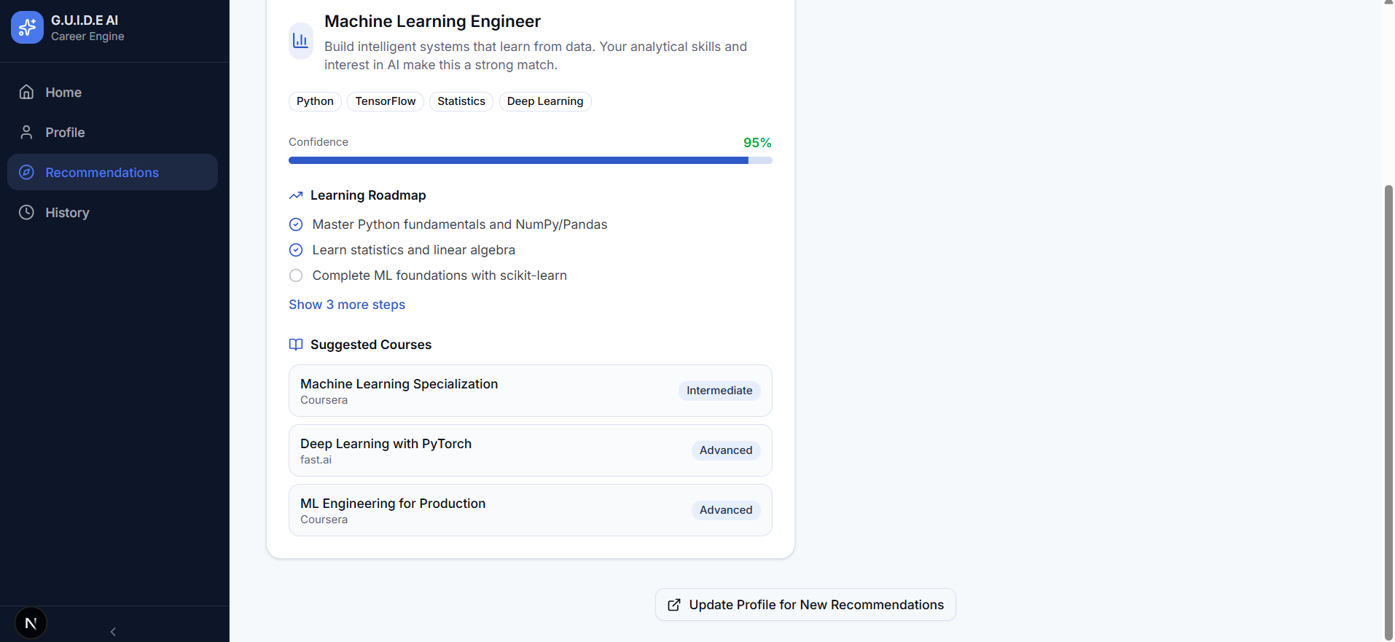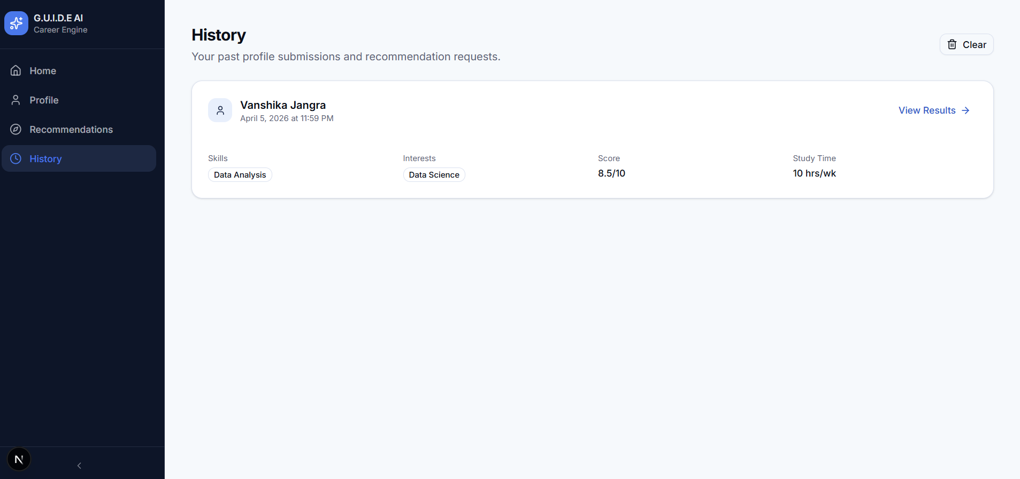

VII.CONCLUSION

This project, shows the full implementation of an AI based career guidance system including frontend, backend integration and AI integration and is successfully able to model user flow , user interation and recommendations given by the AI.

IX. References
[1] J. Bobadilla, F. Ortega, A. Hernando, and A. Gutiérrez, “Recommender systems survey,” Knowledge-Based Systems, vol. 46, pp. 109–132, 2013.

[2] X. Su and T. M. Khoshgoftaar, “A survey of collaborative filtering techniques,” Advances in Artificial Intelligence, vol. 2009, 2009.

[3] P. Lops, M. De Gemmis, and G. Semeraro, “Content-based recommender systems: State of the art and trends,” in Recommender Systems Handbook, Springer, 2011.

[4] F. Ricci, L. Rokach, and B. Shapira, Introduction to Recommender Systems Handbook, Springer, 2015.

[5] G. Adomavicius and A. Tuzhilin, “Toward the next generation of recommender systems,” IEEE Transactions on Knowledge and Data Engineering, vol. 17, no. 6, 2005.

[6] R. Burke, “Hybrid recommender systems: Survey and experiments,” User Modeling and User-Adapted Interaction, vol. 12, no. 4, 2002.

[7] S. B. Kotsiantis, “Supervised machine learning: A review of classification techniques,” Informatica, vol. 31, 2007.

[8] T. Mitchell, Machine Learning, McGraw-Hill, 1997.

[9] I. Goodfellow, Y. Bengio, and A. Courville, Deep Learning, MIT Press, 2016.

[10] J. Leskovec, A. Rajaraman, and J. Ullman, Mining of Massive Datasets, Cambridge University Press, 2020.

[11] D. Zhang et al., “Artificial intelligence in education: A review,” IEEE Access, vol. 8, 2020.

[12] S. Russell and P. Norvig, Artificial Intelligence: A Modern Approach, Pearson, 2021.

[13] M. Pazzani and D. Billsus, “Content-based recommendation systems,” The Adaptive Web, Springer, 2007.

[14] Y. Koren, R. Bell, and C. Volinsky, “Matrix factorization techniques for recommender systems,” IEEE Computer, vol. 42, no. 8, 2009.

[15] H. Drachsler, K. Verbert, O. C. Santos, and N. Manouselis, “Panorama of recommender systems in education,” International Journal of Technology Enhanced Learning, 2015.

[16] J. L. Herlocker et al., “Evaluating collaborative filtering recommender systems,” ACM Transactions on Information Systems, 2004.

[17] B. Schafer, J. Konstan, and J. Riedl, “E-commerce recommendation applications,” Data Mining and Knowledge Discovery, 2001.

[18] N. Thai-Nghe et al., “Factorization techniques for predicting student performance,” Educational Data Mining, 2010.

[19] A. S. Ashour et al., “Career recommendation systems using machine learning,” International Journal of Advanced Computer Science and Applications, 2018.

[20] K. Paparrizos et al., “Machine learning approaches for career path prediction,” IEEE Conference Publications, 2011.

